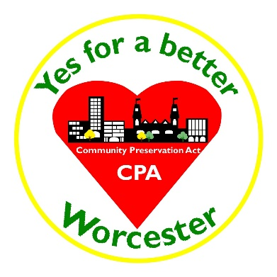
Community Preservation Act (CPA) in
Worcester: A Fact Sheet
What is the Community Preservation Act?
The CPA is a Massachusetts program which allows communities to create a local fund dedicated to open/recreation spaces, historic resources, and housing. CPA has been adopted by 172 communities including, Springfield, New Bedford, Pittsfield, Grafton, Upton, Sturbridge, Boston, and West Boylston.
What are the benefits of the Community Preservation Act?
The CPA is an opportunity to invest in the community and develop local projects that would otherwise be overlooked by regular municipal budgeting processes. Since taxpayer money is needed to fund vital places such as schools, police and fire departments, and infrastructure such as roads and freeways, CPA would provide money for projects that enhance communities through aesthetics, historical significance, recreation, and addressing housing needs that contribute to a community’s unique characteristics in addition to strengthening a community’s financial outlook.
If the CPA is successfully passed in Worcester, citizens can ensure that such local projects will not fall by the wayside of publicly funded programs and not only make it a better place to live for the public but also attract prospective residents and businesses. Passage of the CPA in Worcester can help ensure that more homeowners are able to thrive in our city!
How is Community Preservation Act funded?
There are two sources: one is a small voter-approved surcharge on the tax levy against real property. The other is a yearly distribution from the statewide CPA Trust Fund, whose revenues come from Registries of Deeds filing fees. Since 2001, more than $592 million has been given from the fund to cities and towns but Worcester has received none of these funds. And in order to receive them, the City must vote to adopt the Community Preservation Act.
How can Community Preservation Act funds be spent?
CPA funds can be used only for open/recreation spaces, historic resources, and housing. A minimum of 10% of CPA funds must be allocated annually for each of those categories. The remaining 60-65% can be distributed among those categories based on the community’s needs. The allocation of these funds is a public process and community groups, nonprofits, businesses and government organizations are eligible to receive funding.
What is being proposed on the November 6th ballot?
CPA will be a ballot question this November. A yes vote will adopt CPA with a 1.5% surcharge on property taxes*. There will be an exemption for the first $100,000 of property value and an exemption for owner-occupants who are low income families or low/moderate income seniors (as defined by federal HUD guidelines).
How much would Community Preservation Act cost the average Worcester homeowner?
The average single-family homeowner would pay approximately $32/year or $2.67/month and the average three-decker homeowner would pay approximately $36/year or $3/month.
How much would Community Preservation Act generate for Worcester?
CPA would annually generate more than $3,000,000 from the local surcharge to be used for eligible projects. By adopting CPA, Worcester will also receive annual additional funding from the statewide CPA Trust Fund.
What kinds of projects can be funded with Community Preservation Act?
CPA can assist a wide variety of projects in the three eligible categories including • Creation or restoration of parks, playfields, playgrounds, and bike paths • Creation of community gardens and preservation of conservation areas • Restoration of historic buildings such as libraries, schools, houses and houses of worship • Creation of programs which meet local housing needs or assist first-time homebuyers.
How is Community Preservation Act administered after adoption?
The City Council will create a Community Preservation Committee which is composed of members appointed by the Historical Commission, Conservation Commission, Park Commission, Housing Authority, Planning Board, and up to four other members appointed by the council. The Committee will solicit community input and proposals and review project proposals to ensure compliance with state requirements. These will then be submitted to the City Council for approval. City administrators will provide oversight to ensure appropriate use of funds.

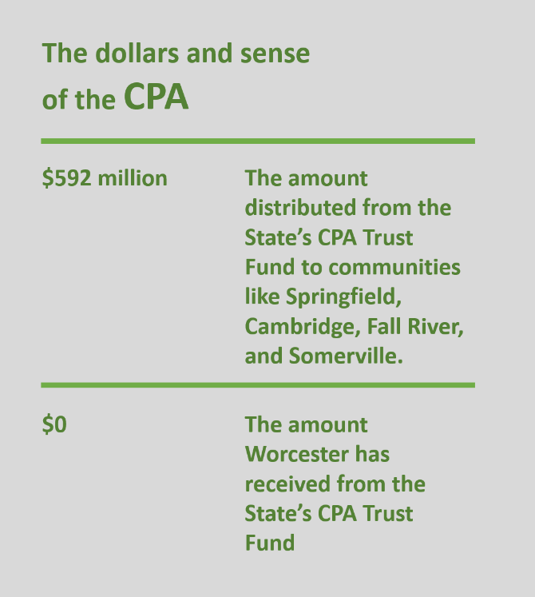
*Once adopted, the CPA surcharge percentage and exemptions cannot be changed without a vote by Worcester residents

